

**ROBOTAXI-FULL SCALE AUTONOMOUS VEHICLE**

**COMPETITIONSPECIFICATION**

1

|  |  |  |
| --- | --- | --- |
| **CONTENTS** | |  |
| **1** | **PURPOSE ......................................................................................................................................** | **4** |
| **1.1.** | **Competition Categories ................................................................................................................** | **4** |
| **1.2.** **CONDITIONS FOR PARTICIPATION IN THE COMPETITION .......................................** | | **5** |
| **2** | **COMPETITION DUTIES ...........................................................................................................** | **6** |
| **2.1.** **Track ...............................................................................................................................................** | | **6** |
| **2.2.** | **Trails and traffic signs ..................................................................................................................** | **7** |
| **2.3.** | **Mission .........................................................................................................................................** | **10** |
| **2.4.** | **Simulation ....................................................................................................................................** | **12** |
| **3** | **Contest Reports And Presentations ..........................................................................................** | **13** |
| **3.1.** | **Preliminary Design Report ........................................................................................................** | **14** |
| **3.2.** | **Preliminary Design (Simulation) Presentation .........................................................................** | **14** |
| **3.3.** | **Critical Design Report ................................................................................................................** | **15** |
| **3.4.** | **Vehicle Test Video .......................................................................................................................** | **15** |
| **3.5.** | **Contest Evaluation Presentation ...............................................................................................** | **16** |
| **4** | **VEHICLE GENERAL SPECIFICATIONS ............................................................................** | **17** |
| **4.1.** | **Physical Properties ......................................................................................................................** | **17** |
| **4.1.1.** **Vehicle Dimensions ..................................................................................................................** | | **17** |
| **4.1.2.** **Car Body ...................................................................................................................................** | | **17** |
| **4.1.3.** **Weight .......................................................................................................................................** | | **17** |
| **4.1.4. Wheels .......................................................................................................................................** | | **18** |
| **4.2.** | **Sensor / Sensing System ..............................................................................................................** | **18** |
| **4.3.** | **Security Hardware ......................................................................................................................** | **18** |
| **4.3.1.** **Remote Emergency Response System (RERS) ......................................................................** | | **20** |
| **4.3.2.** **Control System .........................................................................................................................** | | **20** |
| **4.3.3.** **Wireless Communication System ...........................................................................................** | | **20** |
| **4.3.4.** **Assembly and Wiring Elements ..............................................................................................** | | **21** |
| **5** | **SUPPORTS AND AWARDS .....................................................................................................** | **22** |
|  | 2 |  |

|  |  |  |  |
| --- | --- | --- | --- |
| **5.1.** **Supports ........................................................................................................................................** | | | **22** |
| **5.2. Awards and Rules .......................................................................................................................** | | | **22** |
| **5.2.1.** **Minimum Success Criteria for Award Ranking ...................................................................** | | | **23** |
| **6.** **EVALUATION ...............................................................................................................................** | | | **24** |
| **7.** | **COMPETITION .........................................................................................................................** | | **25** |
| **7.1.** **Pre-Competition Activities ........................................................................................................** | | | **26** |
| **7.1.1.** **Delivery of Preliminary Design and Simulation Report .................................................** | | | **26** |
| **7.1.2.** **Display of Preliminary Design Report Presentations and Simulation ...........................** | | | **26** |
| **7.1.3.** **Submission of Critical Design Report ...............................................................................** | | | **27** |
| **7.2.** **Activities During the Competition ............................................................................................** | | | **27** |
| **7.2.1.** | | **Technical Controls ..............................................................................................................** | **28** |
| **7.2.2.** | | **Competitions ........................................................................................................................** | **28** |
| **7.2.3.** **Competition Report and Presentation ..............................................................................** | | | **29** |
| **7.2.4.** | | **Evaluation ............................................................................................................................** | **29** |
| **8.** | **COMPETITION SCHEDULE ..................................................................................................** | | **29** |
| **9.** **GENERAL RULES & REGULATIONS .................................................................................** | | | **31** |
| **10.** **ETHICAL RULES .......................................................................................................................** | | | **32** |
|  | **Statement of Liability ..................................................................................................................** | | **33** |

3

**IMPORTANT UPDATES**

* The condition of having at least 3 people in the Unique Vehicle Category and at least 5 people in the Autonomous-ready Vehicle Category was introduced.
* Vehicles must have an active signal system.
* The stops will now be located in areas parallel to the road.
* Random obstacles can be found in the track. In this case, the vehicle is expected to re-route.
* No competitor can follow the vehicle closely during the active competition. All interventions must be made remotely and at the specified location. It is obligatory to follow the instructions given by the Competition Committee.
* Barriers on the track will no longer be found.
* The entire competition process will be passed with a single draw.
* There may be parking areas for the disabled.
* Rewards have been updated.

4

Autonomous vehicles now cease to be imaginary, as illustrated in the 90s science fiction series. Today, many technology companies carry out research and development activities on this issue with large budgets. Currently, autonomous vehicles are cruising in urban traffic in some pilot areas of the United States. Developments in automatic driving / autonomous vehicles will continue to accelerate and these concepts will take a serious place in the concept of mobility in 2030 and beyond.

According to 2015 data of the Turkish Statistical Institute (TUIK), driver defects constitute 90% of the defects that cause traffic accidents. Its contribution to traffic safety is quite high, as autonomous vehicles minimize human error. In addition, factors such as improper route selection and selfish driver behavior, which are of great importance in traffic density, can be eliminated by autonomous vehicles. Therefore, autonomous vehicles will be indispensable elements of the cities of the future.

*In the rest of the competition specification, robotaxi-passenger autonomous vehicle will be mentioned using the name “robotaxi”.*

**1 PURPOSE**

Robotaxi competition has been prepared in order to ensure the development of autonomous vehicle technologies in the world.

**1.1. Competition Categories**

The competition contains two categories;

* **Unique Vehicle Category**
* **Autonomous-ready Vehicle Category**

**1.1.1. Unique Vehicle Category**

It includes teams that will participate in the competition with a vehicle that meets the conditions specified in the "Vehicle General Features (Chapter-5)" section.

**1.1.2. Autonomous-ready Vehicle Category**

A fully equipped electric vehicle platform with drive-by-wire will be provided by the TEKNOFEST Committee for teams that want to make software improvements only.

Fully equipped vehicle platforms will not be given one for each team. These vehicle will be available for common use. The fully equipped vehicle is planned to include equipment such as distance sensor, camera, communication system, control card. The teams must develop the necessary algorithms and software themselves by processing the data from the necessary sensors in the vehicle. The model of the fully equipped vehicle in the simulation environment and the necessary APIs will be shared with the teams. After the preparation phase of the fully equipped vehicles is completed, the vehicles will be available for the teams that have passed the required stages. The periods of use of the vehicles will be arranged by the appointment system. In this way, teams will be able to test their software on vehicles before the day of the competition. Technical features and user manual of the fully equipped vehicle platform will be shared with the teams later.

Competition duties and contents are the same for both categories, and changes can be made to signs and traffic lights etc.

5

**1.2.** Contest Reporting Process

**1.2.1.** Preliminary Design and Simulation Report

**1.2.2.** Critical Design Report

**1.2.3.** Vehicle Test Video

**1.3. CONDITIONS FOR PARTICIPATION IN THE COMPETITION**

**1.3.1. TEAM**

* High school, university students and graduates can participate in the competition asteams.
* Teams are not required to be a school (University/High School) Club.
  + Teams can be formed from a one school, or they can also be formed as a mixed team by combining one or more high school/higher education students.
* Teams;

It must consist of at least 3 and maximum 20 people in the Autonomous-ready Vehicle Category o Numbers do not include consultant.

It Must consist of at least 5 and maximum 20 people in the Unique Vehicle Category. o Numbers do not include consultant.

* + The competition consists of two categories: Unique Vehicle Category and Autonomous-ready Vehicle Category.

**1.3.2. APPLICATION**

* Applications made to the competition are received separately from the Unique Vehicle and Autonomous-Ready Vehicle categories.
  + Teams can only register for one category.
  + A member of a team cannot be a member of another team.
  + Each team that will apply for the Unique Vehicle Category can participate in the competition with only one vehicle.

**1.3.3. EDUCATION**

* High school teams must be counselors.
* A consultant must upload a document that they will receive from the relevant educational/educational institutions where they work, along with a preliminary design report, to thesystem.
* The role of the advisor in the team is to provide the academic support that will be needed in the project, to guide the team members to find solutions to their problems.
* Undergraduate, graduate and graduate level teams can recruit a lecturer/member or research assistant as a consultant.

**1.3.4. ADVISOR**

* Each team must have only one advisor.
* An advisor can only advise one team.
* The advisor must submit the assignment letter to the TEKNOFEST Committee to be received from the relevant educational/training institutions in writing. (The consultant must provide this document in the change.)
* If there is a change of Advisor, they must submit it in writing to the relevant TEKNOFEST Committee.

6

* The duty of the consultant; to help students to plan their own education, to guide them in academic, social and cultural issues, to help the preparation of the appropriate environment for the development of the student's personality as a whole with social and emotional aspects, etc. tasks andservices.

**1.3.5. OTHERS CONDITIONS**

* + The teams that have been finalists in the past years must have developed their projects / vehicles / autonomous software and must indicate in their reports the information that they have participated in the competition before.
  + Applicants to the competition are deemed to have accepted all of the above conditions.
  + The deadline for submission of the application form is March 07, 2022. Team information and contact numbers will be specified in the application form. Applications will be made through the official website of the Aerospace and Technology Festival TEKNOFEST Technology Competitions ([www.teknofest.org](http://www.teknofest.org/)).

1. **COMPETITION DUTIES**

Robotaxi will serve on a track that reflects the state of full-scale city traffic. The vehicle's task is to travel on an inner-city route, starting from a fixed point (BN: starting point) and ending at an end/stopping point (DN: ending/stopping point), similar to a typical urban taxi. During this trip, robotaxi will stop when it sees the first passenger pick- up sign (or: passenger pick-up point), pick up the passenger and continue its journey. Robotaxi will drop the received passenger at a marked point (YB: passenger drop-off/drop-off point) on its route. Robotaxi will follow traffic rules throughout the trip and stop when it reaches the end point. Robotaxi, which parks in the first empty space in the parking areas at the end of the endpoint, will have successfully completed its task.

**2.1. Track**

Robotaxi will serve on a full-scale course. An example of this course is seen in Figure 1. A more detailed technical picture of this course will be announced to the contestants by May 30, 2022. The final plan of the course will be given to the contestants before the technical checks are carried out before the competition.

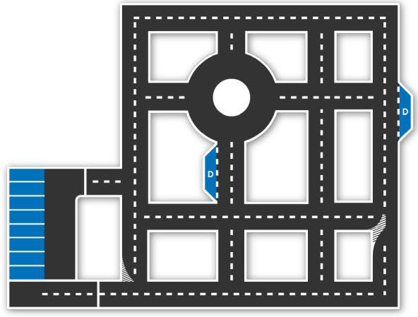

*Fig 1 An example of a track where a full-scale autonomous vehicle will serve.*

7

*During the week of competition, this course remains the same overall, but may include some changes.*

As in normal traffic, the vehicle will be expected to move within the lane. If the vehicle leaves the lane completely, the right to race will be terminated. Lines will be straight, except at intersections. The starting point of the track will be marked with a straight line perpendicular to the course of the track. The end point will similarly be marked with a straight line perpendicular to the road. These lines will resemble stop lines used in traffic (see Figure 5).

Apart from this, there will be many traffic signs on the track. Typically there may be speed limit, direction signs, turn ban signs, crosswalk signs, traffic lights and stop signs.

The path that robotaxis will follow will be determined by lane signs. There will be barriers for security purposes, at least 1m outside these lanes. There will be no barriers or visual signs between the lanes and barriers other than traffic signs and lights. There will be no pavement or similar elevation before the barriers. The height of the barriers is expected to be between 50cm and 100cm.

The robotaxi parking area is arranged so that the vehicle can park upright. The entrance to the parking spaces will be open. The other three sides will be indicated by straight and continuous white lines. The above-mentioned barriers will be 1m beyond the remaining part of the vehicle opposite the entrance to the park. As mentioned earlier, the lanes, traffic signs and lights will reflect the actual situation used in traffic. Only departure (BN) and end (DN) points, two special signs for passenger pick-up (YA) and drop-off (YB) can be defined.

**2.2. Trails and traffic signs**

Various traffic signs will be used along the autonomous vehicle trail, and vehicles will be expected to comply with these signs. All signs shall comply with the traffic signs standards of the General Directorate of highways. These standards can be reached at the link below.

[http://www.kgm.gov.tr/SiteCollection Documents/KGMdocuments/Trafik/IsaretlerElKitabi/TrafikIsaretleriElKita](http://www.kgm.gov.tr/SiteCollectionDocuments/KGMdocuments/Trafik/IsaretlerElKitabi/TrafikIsaretleriElKitabi2015.pdf)

[bi2015.p](http://www.kgm.gov.tr/SiteCollectionDocuments/KGMdocuments/Trafik/IsaretlerElKitabi/TrafikIsaretleriElKitabi2015.pdf)

[df.](http://www.kgm.gov.tr/SiteCollectionDocuments/KGMdocuments/Trafik/IsaretlerElKitabi/TrafikIsaretleriElKitabi2015.pdf)

A few examples of traffic signs to be used in the competition and their dimensions are shown below:

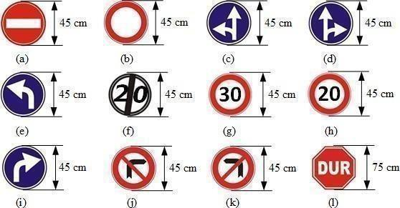

8

*Fig 2 Examples and measurements of traffic signs*

*In the competition; It should not be forgotten that it can be used in other traffic signs that are not mentioned above and that comply with the standards of the Turkish General Directorate of Highways.*

Definitions of traffic signs are listed below;

* no way in
* closed road to vehicle traffic
* forward and left mandatory direction
* forward and right mandatory direction
* forced direction from ahead to left
* end of speed limit (20 km / h)
* maximum speed limit (30 km / h)
* maximum speed limit (20 km / h)
* mandatory direction from ahead to right
* don't turn right
* do not turn left
* stop

The location of the traffic signs next to the road is shown in the figure below.

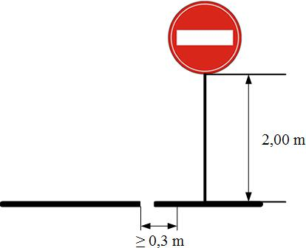

*Fig 3 Location of traffic signs*

Parking and stop signs are shown in the next figure.

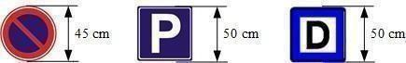

9

*Fig 4 No parking (left), Parking lot (middle), Stop (right)*

Next to them, the starting point will be a single line white, seamless and 50 cm wide. The stop point will be like the starting point.

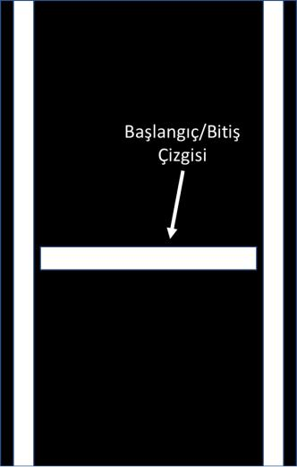

*Fig 5 Start and end points-Stop Line used in traffic.*

The passenger pick-up point (or) will be the stop sign in the middle shown in Figure 4. The same sign will be used as a passenger drop-off sign.

The traffic light measures to be used are shown below.

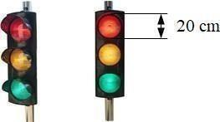

*Fig 6 Trafik Lights*

The measurements of the parking area are shown in the figure below. The color and thickness characteristics of the parking lot line will be similar to the regular parking lot lines in traffic.

10

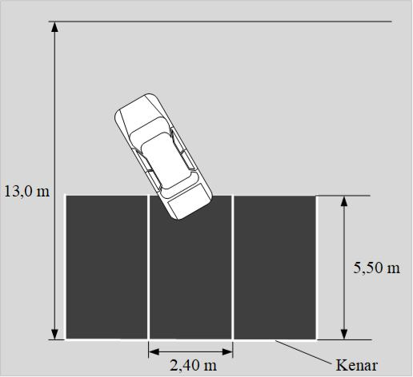

*Fig 7 parking space*

**2.3. Mission**

Robotaxi will perform a typical task within the city. This task begins with the vehicle moving from the starting point and ends with the vehicle parking after reaching the end point.

Each vehicle participating in the race has 3 rights to complete the mission. The completion time of the task will be communicated to the teams at the time of the competition. The first trial order will be determined by drawing lots. A single lot will be drawn before the start of the races. This drawing order will be taken as basis for trial rights and competition time.

The vehicle that will perform the task will be brought to the starting point by the team. After the vehicle is started, no one will be left on the track except the emergency stop pilot from the team. The vehicle will drive completely alone on the track. *(If the TEKNOFEST Competitions committee deems necessary, it may have people on the track to follow or record the vehicle in a way that does not affect the competition).*

After starting the car, no one from the team will be left on the track except the emergency stop pilot. The operated vehicle must start its operation no later than 60 seconds. A vehicle that cannot start a task within 60 seconds will be considered unsuccessful in this attempt/about.

After the vehicle moves, it will continue on its way, following the traffic rules. The cruising vehicle will stop at the first passenger pick-up sign it sees. In order for the vehicle to successfully pick up passengers, it must stop within the area shown in Figure 8. The vehicle will wait at least 30sec for passenger pick-up. A vehicle moving without waiting for 30 seconds and vehicles waiting for more than 90 Seconds will be considered unsuccessful in the task of receiving passengers.

11

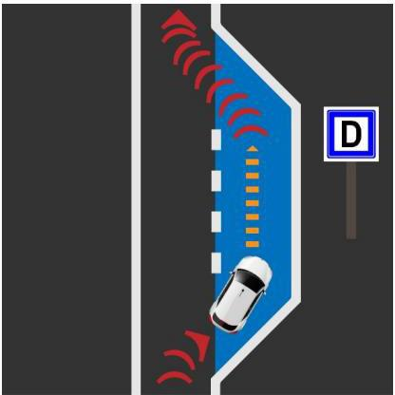

*Fig 8. Stopping process at the stop*

**2.3.1. Receiving Passengers**

Passenger pick-up action will be made at a stop located in a pocket on the main road. It is pictured in Figure 8 above. When your vehicle enters the pocket, it must signal in the direction of the direction. Failure to signal will be reflected in your total score as a penalty point. In the next part, the vehicle will obey the traffic rules while continuing its course. In order for the vehicles to get to the finish point, he will need to decide which route to follow for the remainder of the mission. The length of the route and the condition of the signs on the road can be effective in this decision.

**2.3.2. Passenger Getting Off**

When the vehicle in motion sees the passenger drop sign, it will unload the passenger. The vehicle must stop within the area shown in Figure 8 for a successful unloading of passengers. The vehicle will wait at least 30 seconds for passenger unloading. Vehicles that move without waiting for 30 seconds and vehicles that wait for more than 90 seconds will be deemed unsuccessful in the passenger drop off mission.

**2.3.3. Endpoint**

When the vehicle reaches the end point, it will have completed the route. This time will be measured. The team that does not reach the finish point within the maximum time will be considered unsuccessful about it.

**2.3.4. Parking**

After the end point, the car will move autonomously to the parking area and park in the first parking place in accordance with the rules. A successful parking is parking and stopping the car without any traffic violation and staying in the lanes. The wheels of the correctly parked car do not touch the lanes that border the parking space. A car parked in accordance with the rules within 3 minutes of reaching the end point will be considered successful in the parking task. The parking area will have a capacity of **at least 3 vehicles**. Some of these will be marked as non-parking.

Parking and parking ban signs are seen in the following figure.



12

*Figure 9 parking and parking ban signs.*

This sign will be placed at the end of the parking spaces. This settlement is seen in the following figure.



*Figure 10 parking signs. Two of the 3 parking spaces are marked as non-parking. The other one is marked as Parkable. These signs will be placed 2m above the ground.*

Robotaxi can choose and park a parking spot without a parking ban. Parking ban areas may be different for each contestant during the competition.

Penalty points will be applied for traffic rule violations during the cruise. Penalty points are described in Section 11.

The vehicle will be monitored with external cameras from the top throughout the race and violations will be recorded. Track referees will instantly monitor the vehicle performing the task and track whether the subtasks are successful.

**2.3.5. In-Mission Restrictions and Requirements**

**2.3.5.1. Limitations**

* Your vehicle is the parkour task; must be completed within the time period to be announced by the referee committee on the day of the competition.
* If the mission/track is not completed within the specified time, the vehicle is stopped on the track and the mission is terminated.
* There are lane narrowing on the track.
* The vehicle must change lanes in accordance with the rules.
* The vehicle must signal when changing lanes.

**2.3.5.2. Requirements**

* Each team must bring their own monitor, keyboard and mouse to use the vehicle during the test and competition process.

13

**2.4. Simulation**

**2.5.**

In any simulation environment, a simulation that meets all the requirements set out in this specification will be performed, reported (preliminary design report) and submitted orally to the evaluation board (see warnings and precautions). 8.2.).

**2.4.1. Purpose**

The aim of the simulation is to demonstrate the skills necessary for the implementation of the tasks in the TEKNOFEST robotaxi competition by the teams in a simulation environment. Simulation results are highly weighted in the preliminary design report Evaluation (see simulation results). 7.1). Therefore, the success of the simulation study is important in the determination of the competition teams to be given autonomous car kit.

**2.4.2. Simulation Requests**

Teams are free to choose the simulation environment. Gazebo, Unity, Unreal Engine, LGSVL/Simulator, Matlab etc. all simulation environments are convenient to use.

Only Gazebo media should be used for the Autonomous-ready Vehicle Category.

It is expected that the algorithms and software that will be developed in the simulation environment will be adapted and used to the real tool (in case of acceptance of teams to the competition).

Vehicles and equipment (sensors such as LIDAR, RADAR, camera, GPS) that will be identified in the simulation environment must be compatible with the vehicle design that the teams offer in the preliminary design. Sensors that will not be used on the vehicle provided for in the preliminary design should also not be used in the simulation.

**2.4.3. Simulation**

All teams in the simulation program of their choice, the Robotaxi race rules described in detail in this specification (see robotaxi race rules). 3.1,2, 3) models the race track in the frame. The course to be created in the simulation environment must be suitable for Performing Race tasks. Therefore, the course in the simulation environment must include the course given at least in Figil1. All teams inthe simulation program of their choice, in accordance with the Robotaxi properties (physical properties) described in detail in this specification (see below). 5.1.,5.2,5.3.) models vehicle and autonomy sensors.

All teams complete the simulation in their chosen simulation program by developing algorithms and software that will perform the Robotaxi vehicle competition tasks described in detail in this specification. It is expected that the team will make the criteria determined in the competition as a result of the simulation using the modeled tools and algorithms (Table 3).

**2.4.4. Reporting**

The video of the simulation will be uploaded to Youtube before the time specified in the competition calendar and its name/Link will be included in the preliminary design report. Team information should be included in the video to be uploaded. No changes will be made to the video after the date specified in the calendar. *This video is considered proof of concept.*

14

1. **Contest Reports And Presentations**

As part of the competition, teams will be asked for preliminary design and critical design reports. In addition, teams are expected to make two different presentations together with the preliminary design report and at the end of the competition.

These reports and presentations are an important part of the competition and will be included in the evaluation.

**3.1. Preliminary Design Report**

Each team applying for the robotaxi competition is required to prepare preliminary design and simulation reports by the deadline specified in the competition calendar and submit their reports via the link announced on the competition web page. Teams that do not deliver their reports by the specified deadline will be considered unsuccessful and will not be eligible to participate in the competition.

Preliminary design and simulation reports of the teams applying for the robotaxi competition will be evaluated and scored by the Robotaxi competition Advisory Board and judges in accordance with the “preliminary design and simulation report template”. As a result of the evaluations, the teams that will be accepted to the competition will be determined, and the teams that will not be accepted to the competition will be eliminated. Evaluation results of preliminary design and simulation reports will be announced to the teams on the date specified in the competition calendar.

*Preliminary design and simulation report template will be posted on the competition website.*

**3.2. Preliminary Design (Simulation) Presentation Video**

All teams registered for the Robotaksi Competition have to prepare (submit) a preliminary design report and create a presentation video in order to move on to the next stage (second presentation/report, support, being able to compete, award, etc.).

The evaluation criteria given below should be used for the content of the presentation video to be made.

* Creating a racing track in any simulation environment
* Creation of the vehicle and sensors in accordance with the specified technical requirements in the simulation environment
* Performance of tasks (will be shown through the selected simulation program during the presentation)
* The results of the study should be sufficient and meaningful, supported by graphics and figures
* As a result of the student's preliminary design work, the plan and program for the future stages
* Modern engineering software and hardware selection/use
* Required background work and analysis
* Including the necessary technical data (all technical data must be included in the preliminary design report)
* Professional presentation skills

|  |  |  |
| --- | --- | --- |
| **▪** | P |  |
| **▪** |  |

resentation video durations will be a maximum of 10. It should be noted that video durations will not be 15

flexible. Teams have to explain the simulations they include in their reports during the presentation video. Preliminary design report and presentation video will be evaluated according to the template to announced on the website. The teams to be supported will be determined according to the score ranking that will be formed by the evaluation of the preliminary design report and presentation as stated in the appendix.

**3.3. Critical Design Report**

Each team accepted to the competition is required to prepare critical design reports by the deadline specified in the competition calendar and submit their reports via the link announced on the competition web page. Teams that do not deliver their reports by the specified deadline will be considered unsuccessful and will not be eligible to participate in the competition.

Critical design reports of the participating teams in the robotaxi competition will be evaluated and scored by the Robotaxi competition Advisory Board and judges in accordance with the “Critical Design report template”. As a result of the evaluations, the teams that will be accepted to the competition will be determined, and the teams that will not be accepted to the competition will be eliminated. The evaluation results of the critical design reports will be announced to the teams on the date specified in the competition calendar.

*The Critical Design report template will be posted on the competition website.*

**3.4. Vehicle Test Video**

Vehicle Test video is a continuous video showing that the vehicle participating in the competition is working safely, acting autonomously, can move in the desired direction. The video content contains two sub-videos. The first lower video takes the driver's seat and steering wheel into full frame. The second sub-video fully frames the vehicle and its movement from outside the vehicle. Example Video template 1 can be seen as an example. Both videos should be shot at the same time. The vehicle Test video should also show that the vehicle can go 20 meters along the road. From the moment the car starts acting autonomously, it must be shown that the car can move from one point to another on a straight road. The resolution of the video should be at least 720p, and the total duration should be at least 3 minutes, at most 5 minutes. In order to participate in the competition, the video must be sent by the date **specified in the competition calendar.**

According to the results of the vehicle Test videos, the teams that qualify for the final will be announced on the date specified in the competition calendar.

16

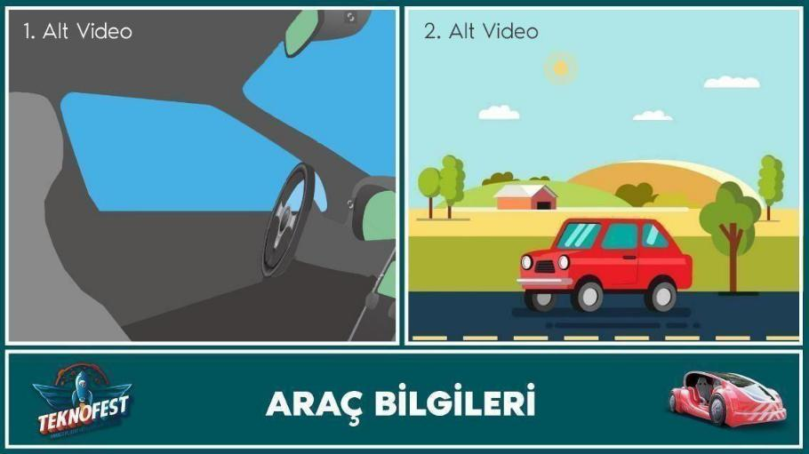

*Sample Video Template 1*

**3.5. Contest Evaluation Presentation**

Robotaxi-all teams registered in the passenger autonomous vehicle competition must prepare (submit) and make a presentation of the “competition Evaluation Report” so that they can evaluate and receive awards.

The evaluation criteria given below should be used for the content of the presentations to be made. Explanation of the block diagram containing all the systems of your autonomous vehicle, brake used, what the steering systems are, how the structure is controlled by giving information (This should be supported by materials such as drawings, photographs.)

A description of the simulation program that you use and a description of the simulation race course that you have prepared in the presentation. Adding a video about this topic to the presentation. Specifying the reason why the simulation program you are using ispreferred.

Sensors (LIDAR, camera, etc.b.) demonstration of their assembly on the vehicle and indicating the reasons for their preference. Introduction of the autonomous control platform (hardware) you use, indicating why you prefer it.

The sensor data used in the competition process should be indicated in the presentation in the form of graphics, tables, the camera image should be recorded and added to the presentation during the race (in the same way, LIDAR images should be added to the presentation, if any.)

Comparison of simulation results and competition results with graphics andfigures.

Providing information about whether each competition task has been accomplished or not, explaining the reasons why it has been partially accomplished or not, specifying what equipment, algorithms, methods they should use to succeed the task.

Indicating their achievements from this competition.

Exhibiting professional presentation skills.

17

Presentation time, 15 min. the presentation will be + 5 min Q & A. It should be known that presentation times will not be flexible. The technical competence of the project team will be tested in question and answer section. This report and presentation template will be posted on the websit

1. **VEHICLE GENERAL SPECIFICATIONS,**

Teams that will compete in the Unique Vehicle Category must meet the features specified in this section. General features of the Autonomous-ready Vehicle will be shared later.

**4.1. Physical Properties**

It is expected that the vehicles will be passenger vehicles suitable for urban driving. For this purpose, vehicles (within the specified dimensions) are required to have at least one seat or more seats, 4 wheels (for the driver with a height of about 1.70 m and a weight of 70 kg).

**4.1.1. Vehicle Dimensions**

1. the height of the vehicle must be at least 100 cm and less than 1.25 times the width of the vehicle. (100 cm < vehicle height < vehicle width x 1.25 (150-225cm)).
2. the distance between the mutual wheels must be more than half the width of thevehicle.
3. vehicle width should not be less than 120 cm, not greater than 180 cm (119 cm < vehicle width <181 cm).
4. the vehicle length must be at least 200 cm and at most 425 cm.
5. the opening of the front wheels must be at least 100 cm, and the opening of the rear wheels must be at least 80 cm.
6. the distance between the front and rear wheels must be at least 130 cm.
7. the vehicle's ground clearance must be at least 45 mm.
8. there is no lower limit on vehicle weight, it is unsafe for the Advisory Board and the Arbitration Committee (see warnings and precautions). 4.3) vehicles whose doors and other components it believes will be damaged in the wind will be exported due to a security violation.
9. during technical checks, the vehicle will be checked to see if it is in the lines drawn in the control area.

**4.1.2. Car Body**

* 1. The vehicle body must be fixed to accommodate all mechanical and electrical parts. When looking at the car from the front, back and top, all parts must be completely inside the body, the wheels can move out of the shell (e.g. Formula cars). The Shell must not contact the road, wheel or any other hitch.

1. in cases that require the installation of brake wires, pipes, hoses, electrical cables and electrical equipment outside the vehicle, these components should be protected from the risks of damage such as Stone impact, rust, mechanical failure. All components to be installed in the vehicle Shell must be protected from risks such as combustion and short circuit.
2. the body of the car should not have sharp and sharp protrusions that may damage the track during the race.

During technical checks, all elements that pose a risk to the track or other vehicles will be checked.

18

1 TUBITAK Efficiency Challenge electric vehicle racing activity booklet was used in the preparation of this title.

**4.1.3. Weight**

There is no lower limit on vehicle weight. However, if the car is not suitable for safety equipment, it may be expelled from the race by the Advisory Board and the Arbitration Committee.

**4.1.4. Wheels**

1. the wheel to be used in vehicles should consist of hub, rim and tire. It is mandatory to use air tires on wheels.
2. heating or chemical treatment of wheel tires by any method is prohibited.
3. there are no restrictions on the wheel dimensions of the wheels and the material in which they are made.
4. the wheel width must be at least 70 mm.

**4.2. Sensor / Sensing System**

The geometry of the road (lanes) and recognition of obstacles can be done by means of cameras or other sensors. One or more sensors can be used to detect the position and environment of the vehicle and help perform the given autonomous task.

The sensor must be securely mounted in the vehicle. The area should not exceed the envelope that determines the surface of the vehicle. This area is limited by the outer edges of the 4 wheels horizontally and by the front rear end points. Except for the sensor, it can exceed the vehicle height by maximum 30 cm.

There will be a "Sudden Brake Duty" at a determined point on the competition track. Within the scope of this task, it will be requested to stop without hitting during movement against pedestrians and similar situations that may unexpectedly set off/jump in urban traffic.

**4.3. Security Hardware**

The vehicle that will participate in the race must include security measures that will not endanger the safety of life and property. Some general rules are listed in this section. The Advisory Board and the Arbitration Committee have the authority to update this list, provided that it is announced in case of need. The Advisory Board and the Ground Jury can determine the vehicles that may pose a risk before or during the race and dismiss them from the competition.

Your vehicle must have brake, right and left turn signal lights. The diameter of the reflection surface of these lights cannot be less than 7 cm and the amount of light cannot be less than 500 lumens.

Vehicles that can participate in the autonomous vehicle category; If they are in the Electromobile or Hydromobile category, the vehicle specifications, safety equipment, TEKNOFEST TUBITAK Efficiency Challenge Electric Vehicle, the Activity Booklet (Rules) prepared for the Hydromobile vehicle must comply with the content. The vehicle features and safety equipment of the vehicles that will compete in the Formula Student category must comply with the Event Booklet (Rules) prepared for the Formula SAE competition. Vehicles found to be unsuitable will be dismissed by the Advisory Board and the Ground Jury.

Autonomous Hydromobile infrastructure vehicles can participate in the competition as long as the working conditions of the battery and fuel cell module are followed, as long as safety measures are followed. There is no limitation in the selection of motor and motor driver. The battery pack must be

19

placed inside the vehicle and protected from short circuit and leakage by a protection container. The battery protection cup should be fixed to a solid point on the floor of the vehicle. Fixing should be done in such a way that the fixing apparatus and fixing points do not move out of place even in the event of an accident. The Battery Management System (BMS) is an electronic system that enables rechargeable battery cells and packs to operate within safe operating limits and its use is mandatory. For this purpose, BMS should monitor the voltage, current, temperature, State of Charge (SOC), State Of Health (SOH) of each battery cell and package and take necessary safety measures when exceeding safe operating limits. BMS should also include passive or active balancing system in order to eliminate voltage imbalances that may occur in battery cells.

In terms of Electrical Safety; All vehicles must comply with the rules set by the national authorities regarding the standardization and use of low voltage electrical components. Although all parts of the electrical equipment should be protected with at least IP 44 type (safe against dust and splashing water), IP 55 type protection is recommended. Any electrical connection between energy generating equipment and energy consuming units must be able to be interrupted by at least one non-sparking circuit breaker (top push emergency power cut-off switch / emergency stop). It is sufficient to have an emergency button. (See Figure 11.a, b, c).

Over

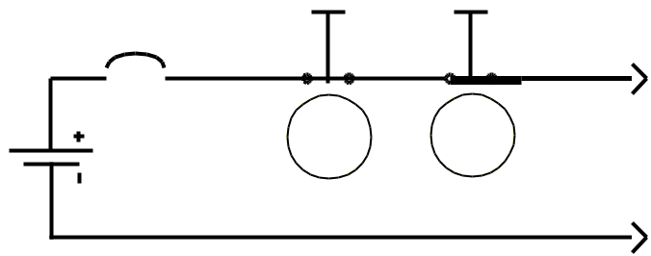

Battery, Fuel

Cell

*Figure 11-a. Example of de-energization circuit with high current emergency disconnect switch*

Over Current Breaker

Contactor

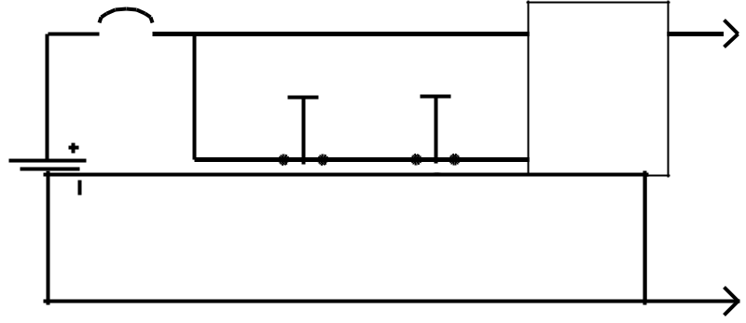

Normally Closed

Switches

Battery,

Fuel Cell

*Figure 11-b. Example of de-energization circuit with low current emergency disconnect switch*

20

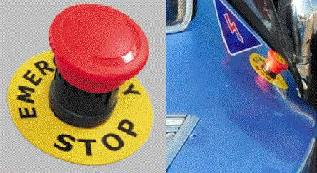

*Figure 11-c. Exapmles of Emergency Power Off (EPO) button*

The emergency disconnect switch should be in a place that can be easily accessed from outside when necessary. In technical inspections, after the other controls of the vehicle are completed, it will be tested whether the emergency stop button works functionally or not by pressing it while the vehicle is running and moving. All electrical cables in the vehicle must be protected by an overcurrent breaker (fuse, etc.) rated for the diameter of each conductor. Overcurrent breakers can in no way replace the circuit breaker (emergency stop button) . Cables must be in a suitable cable sheath and bare cables must not be used. Harnesses should be properly clamped. In addition, the value of the maximum RMS current carried by the cables used in the vehicle should not exceed 5 times the cross-section of the cable used in mm2. (For example, the maximum current that can pass through the 16mm2 cable used in the vehicle should be 80A RMS.) . The braking performance of the vehicle will be controlled by applying the brakes. The test will be done on the brake ramp (slope is about 10 degrees) or the 650 Newton thrust test will be provided by two people pushing the vehicle. The wheels of the pushed vehicle should not turn. The brakes of the vehicle whose wheels turn while being pushed are not suitable. A stop lamp should be placed at the rear of the vehicle so that it can be seen from a distance of at least 25 meters during the day, giving a red light and activating in the event of full or half pressing the brake. It will be checked whether the stop lights are easily visible from a distance of 25 meters in technicalcontrols.

**4.3.1. Remote Emergency Response System (RERS)**

Autonomous vehicle must have RERS. RERS should have two functions:

1. RERS-1: When the remote emergency stop button is pressed, the vehicle must perform an emergency shutdown.
2. RERS-2: When the "Go" button is clicked, the vehicle should start its mission. This button will replace the starting flag in other races.

RERS circuit on vehicle will be directly connected to the vehicle by cable. In technical controls, it will be tested that RERS-1 and RERS-2 functions are working

**4.3.2. Control System**

The entire movement of the vehicle (road tracking, brake and steering maneuvers) will be carried out by the control system on the vehicle or the computer. This control will be provided by electromechanical systems.

It is recommended that teams use regenerative electric brakes in braking. In addition, it is

21

recommended that the hydraulic brake system be working against possible electrical problems of the vehicle and it should be controlled by the vehicle control computer.

*An electromechanical system attached to the brake pedal can activate the hydraulic brake.*

The correct operation of the software that performs the control algorithms should be demonstrated in technical controls.

*(When showing the software, the functions should be displayed* ***in Medium and High level languages*** *for easy understanding.)*

**4.3.3. Wireless Communication System**

Mission start is given to the vehicle remotely via wireless communication. This system should also fulfill the emergency shutdown function. Team is responsible for showing that wireless communication is not involved in the autonomous driving of the vehicle during the mission. Any changes in the vehicle (changing parameters, updating software, sending commands, etc.) will not be permitted at the time of duty by wireless or other communication.

It is strictly forbidden to communicate in any way with the vehicle, except for the systems mentioned above. The vehicle will never be remotely controlled.

Technical controls of autonomous vehicles will be made according to the following:

1. It will be checked whether the vehicle complies with the rules regardingcommunication.
2. Participants must prove that their vehicles perform the autonomous task. This will be checked by the competition evaluation report and presentation, and by the Advisory Board and the Ground Jury.

**4.3.4. Assembly and Wiring Elements**

Autonomous in-vehicle transmission organs must be structurally and chemically appropriate to their task and reliable in terms of environment.

For this, various issues should be taken into consideration while making assembly and cabling.

**4.3.4.1. Assembly**

* In screw connections, make sure that the nut is fully tightened.
* For fixing the parts that are a certain force or that will be exposed to force in the process and that may rupture / detach as a result of these forces, silicon etc. glue cannot be used

. *(It is not a problem to use it for simple bonding.)*

* Fixing / connecting the sections in critical parts should be done with appropriate connection equipmen bolts, rivets, etc.).
* While the car is ready, no parts should make abnormal movements..
* Unsuitable connection equipment cannot be used.
* Electronic components cannot be installed in two potential moving parts.

**4.3.4.2. Wiring**

* Cables should be chosen according to thetask.

22

* + Cables in contact with hot areas should be insulated from heat.
  + The cable should be protected in cases such as puncture, cut and chipped.
  + Measures should be taken to prevent the cable from being damaged in cases such as compression or pulling (plastic inside copper break, plastic breakage, coming out of connectors or connector breaking, etc.).
  + Harnesses should not be kept free. Strapping equipment such as cable socks should be used.
  + Cables need to be labeled. *(To save time and prevent possible accidents during the competition.)*
  + Power cables should be selected properly, installed in the vehicle, protected and insulated.
  + The color selection of the cables should be in accordance with the standards as possible.
  + For color selection of power cables, the color of (+, plus) line should be **Red** (-,minus) line should be **Black**
  + When using cable ties, care should be taken not to cross the cable and take precautions..
  + Power transmission organs should not be transferred directly and aconnector should be used*. (Direct soldering from card to card etc.)*
  + Data and signal cables should be easy to understand.
  + Areas with the possibility of arcing should be designed against burning.
  + No active conductor should be exposed in a ready-made vehicle.
  + Cables, cable harnesses and any transferring equipment must not touch a moving surface (wheel, etc.).

1. **SUPPORTS AND AWARDS**

**5.1. Supports**

5.1.1. Unique Vehicle Category

* Teams that move to the next stage as a result of the evaluation of the Preliminary Design Report, simulation results and presentations will be entitled to receive support. There is no requirement to participate in the competition for the first time for supports. Individuals can only be part of one team.
* A ranking is made among the teams that pass the first stage according to the points they get. Only the team with the highest score from the teams from the same institution is included in this ranking. The other teams in the ranking will be supported in amounts to be determined by the Competition Committee.

5.1.2. Autonomous-Ready Vehicle Category

* According to the results of the Preliminary Design-Simulation Report and Presentation, the teams that qualify for the next stage will be provided with a certain number of fully equipped drive by wire vehicle platforms that they can work on with the appointment system before the competition and use them in a certain order during the competition. Your related vehicle platforms are planned to be ready by June 2022. This date may be moved to a later date according to the conditions of that day or some technical processes. It is planned that the Autonomous - Ready vehicles will be in the **IT Valley** area and the teams will work on the vehicle platform with the appointment system and make the preparations for the competition.

23

**5.2. Awards and Rules**

Teams that successfully complete their tasks will be eligible to enter the prize ranking.

The awards specified in the table below show the total amount to be awarded to the teams that are eligible for awards, no individual awards will be made. Payment will be made to the advisor of the winning team within the scope of the competition. A payment of 5.000,00 TL will be made to the consultants of our ranked teams.

|  |  |  |  |
| --- | --- | --- | --- |
| **Degree** | **Unique Vehicle Category** | **Autonomous-ready Vehicle Category** | **Consultant** |
| First | 100.000 TL | 75.000 TL | 5.000 TL |
| Second | 75.000 TL | 50.000 TL | 5.000 TL |
| Third | 50.000 TL | 35.000 TL | 5.000 TL |

**Table 2 – Awards**

**5.2.1. Minimum Success Criteria for Award Ranking**

In order for a team to be considered successful and receive an award, the competitor team must meet all the conditions stated below;

* **Picking-up passengers according to the rules**
* **Droping-off passengers according to the rules**
* **Reaching to the parking point**
* **Parking according to the rules**
* **Following the right path**

Teams that fulfill their duties will be considered successful.

When ranking among the teams that fulfill all the tasks, the score is first considered. If the scores are equal, the time to complete the racing circuit is considered.

The first three degrees of the competition are determined primarily among the teams that fulfill the award criteria. If there are not enough teams that meet the prize criteria to fill the first three degrees or if no one team fulfill the award criteria, the vacant degrees fill in the order of points with the teams that fulfill the following criteria in at least one attempt. These teams receive the honorable mention in the "Awards and Rules" section instead of the competition award.

Honorable Mention Criteria:

* Perform at least one of tasks picking-up passengers according to the rules or Droping- off passengers according to the rules
* Reaching the parking zone by following the correct route

When ranking among the teams for the honorable mention, if the scores are equal, the time period for the vehicles to complete the above mentioned honorable mentions tasks is considered. The team that completes the task in less time will rank higher.

24

*For example;*

*If only 2 of the 20 teams participating in the competition fulfill the award criteria, these teams will be ranked first and second according to their points. Since there is no team that fulfill the award criteria for the third place, only the teams that meet the honorable mention award criteria are considered. The team with the highest score among these teams is determined as the third. Even if the score of this team is higher than the first and the second, it is behind these teams because it cannot fulfill the criteria. The first and second teams that fulfill the criteria receive the announced first and second prizes of the competition, while only the third team that fulfill the honorable mention criteria will receive the honorable mention.*

**6. EVALUATION**

The following rules are applied to determine the winning team.

* Robotaxes are scored individually for each given task (see Table 3).
* Robotaxi with the highest score wins the contest.
* In case of equality of scores, Robotaxi completing the task as soon as possible wins the competition.
* If the equality is not broken, these teams are entitled to another competition with the same rules.
* If the equality is not broken under the above conditions, the Advisory Boardand the Arbitration Committee distribute the awards.

|  |  |  |
| --- | --- | --- |
| **Task Type** | **Point** |  |
| **Starting To Move The Vehicle** | 200 |  |
| **Picking-Up Passengers According To The Rules** | 500 |  |
|  |
| **Droping-Off Passengers According To The Rules** | 500 |  |
| **Reaching To The Parking Point** | 500 |  |
|  |
| **Parking According To The Rules** | 500 |  |
| **Following The Right Path (Not Acting in Violation of Reverse Direction)** | 500 |  |
|  |
|  |  |  |
| **Preliminary Design Report Score (Evaluated Out of 100)** | 100 (max) |  |
| **Critical Design Report Score (Evaluated Out of 100)** | 100 (max) |  |
|  |
| **Competition Evaluation Presentation Score** | 100 (max) |  |
| **First Traffic Rule Violation** | -50 |  |
|  |
| **Second Traffic Rule Violation** | -100 |  |

***Table 3 – Task and Penalty Points***

Robotaxi loses its current right and is deemed unsuccessful if it breaks three traffic rules or if it is inactive for more than 3 minutes or exceeds the time allowed to reach the end point. The attempts that are deemed unsuccessful are not taken into consideration.

25

**6.1. EVALUATION EXAMPLE**

For example, three different Robotaxi has performed the following tasks in the course. The scoring of robotaxis and their resulting scores are shown in the table below.

|  |  |  |  |  |  |
| --- | --- | --- | --- | --- | --- |
| **Task** | **Robota** | **Robotaksi B** | **Robotaksi C** | |  |
| **Type** | **ksi A** |  |  |  |  |
|  |  |  |  |  |
| **Starting To Move The Vehicle** | **200** | **200** | **200** |  |  |
|  |  |  |  |  |  |
| **Picking-Up Passengers According To The Rules** | **500** | **500** | **500** |  |  |
|  |  |  |  |  |  |
| **Droping-Off Passengers According To The** | **500** | **500** | **500** |  |  |
| **Rules** |  |  |  |  |  |
| **Reaching To The Parking Point** | **500** | **500** | **500** |  |  |
| **Parking According To The Rules** | **500** | **500** | **500** |  |  |
|  |  |  |  |  |  |
| **Following The Right Path (Not Acting in** | **500** | **500** | **500** |  |  |
| **Violation of Reverse Direction)** |  |  |  |  |  |
| **Preliminary Design Report Score** | 80 | 85 | 90 |  |  |
|  |  |  |  |  |  |
| **Critical Design Report Score** | 90 | 100 | 95 |  |  |
| **Competition Evaluation Presentation Score** | 80 | 80 | 80 |  |  |
|  |  |  |  |  |  |
| **First Traffic Rule Violation** | -50 | 0 | 0 |  |  |
| **Second Traffic Rule Violation** | -100 | 0 | 0 |  |  |
| **Time** | 9:50 | 11:02 | 10:25 |  |  |
| **Total Score** | 2800 | 2965 | 2965 |  |  |
| **Table 4 –Evaluation Example** | |  |  |  |  |

According to the above scoring, Robotaxi C will be in the first place, Robotaxi B will be in the second place and Robotaxi A will be in the third place.

**7. Competition**

Robotaxi competition activities to be held within the scope of TEKNOFEST 2022 consist of two main parts: pre-competition activities and activities to be performed during the competition.

Teams applying to the competition in the robotaxi category, before the competition; They will perform preliminary design and simulation report delivery, preliminary design report presentations and simulation demonstration, and critical design report delivery. During the competition; will perform technical controls, execution of competitions, reports and presentation activities.

The activities carried out will be subject to evaluation by the Robotaxi Competition Advisory Board and Referees. As a result of the evaluations made; The teams that will be accepted to the competition, the

26

teams that will receive support, the teams that will participate in the competition and the teams that are entitled to receive awards will be determined.

Teams that do not fulfill the requirements specified in the competition activities will be deemed unsuccessful; They will not have the right to accept, receive support, participate in the competition or receive prizes.

Throughout the competition period, the teams will be monitored by the team in the Competition Committee on technical issues such as autonomy and automatic control systems and mentoring support will be provided. In addition, information sharing and development meetings can be organized in the facilities to be organized by the Competition Committee and / or on the internet (online) on subjects such as control and simulation systems, autonomy, sensor systems in order for the teams to develop better.

**7.1. Pre-Competition Activities**

The activities to be carried out before the competition explain the activities that the teams will carry out before 22 July 2022, which is the start date of TEKNOFEST 2022.

**7.1.1. Delivery of Preliminary Design and Simulation Report**

Each team applying to the Robotaxi contest is obliged to prepare preliminary design and simulation reports until the deadline specified in the contest calendar and send their reports via the link to be sent to the Team Leader's mail account. Teams that do not submit their reports by the specified deadline will be deemed unsuccessful and will not have the right to participate in the competition.

Teams applying to the Robotaxi competition will prepare their pre- design and simulation reports in accordance with the Pre-Design and Simulation Report Template. Teams that do not specify the information requested in the report template in their reports will be eliminated.

Pre-design and simulation reports prepared by the teams will be evaluated and scored by the Robotaxy Competition Advisory Board and Referees. As a result of the evaluations made, the teams to be accepted to the competition will be determined, and the teams not accepted to the competition will be eliminated. Evaluation results of preliminary design and simulation reports will be announced to the teams on the date specified in the competition calendar.

**7.1.2. Display of Preliminary Design Report Presentations and Simulation**

After the evaluation made by the Robotaxi Competition Advisory Board and the Referees, the teams accepted to the competition will make presentations of the reports they have prepared and perform the simulation demonstration on the date specified in the competition calendar and at the place to be specified with the announcement of the preliminary design and simulation report results in order to receive the support determined for the Robotaxi Competition.

Competition teams will make their presentations one by one. A period of time will be set for the presentation of each team, during this time they will submit their reports to the Robotaxi Competition

27

Advisory Board and Referees. In addition, after the report presentations, a period of time will be determined for the simulation demonstrations, during this time they will present their simulation studies to the Robotaxi Competition Advisory Board and Referees.

Presentations made by the teams; The work will be explained by the team members and will have a question and answer content. A presentation, direct or indirect participation by a non-team member will not be accepted. If such a situation is detected, the relevant team will be deemed unsuccessful and will be eliminated.

Disclosures made outside the deadlines specified for the presentation will not be evaluated by the Robotaxy Competition Advisory Board and Referees.

The time periods determined for the report presentations and simulation demonstrations will be determined by the Robotaxy Competition Advisory Board and Referees, and the preliminary design and presentation report evaluation results will be announced to the teams. In addition, the report presentation and simulation display hours of all teams that are entitled to report and simulation display will be notified to the teams while the preliminary design and presentation report evaluation results are announced.

**7.1.3. Submission of Critical Design Report**

Each team accepted to the competition is obliged to prepare critical design reports until the deadline specified in the competition calendar and *send their reports via the link to be sent to the Team Leader's mail account*. Teams that do not submit their reports by the specified deadline will be deemedunsuccessful and will not have the right to participate in the competition.

Teams applying to the Robotaxi competition will prepare their critical design reports in accordance with the Critical Design Report Template. Teams that do not provide the information requested in the report template in their reports will be considered unsuccessful. Critical design reports prepared by the teams will be evaluated and scored by the Robotaxy Competition Advisory Board and Referees. As a result of the evaluations made, the teams that will participate in the competition will be determined, and the teams that are considered not to participate in the competition will be eliminated.

Evaluation results of critical design reports will be announced to the teams on the date specified in the competition calendar.

*(Depending on the intensity of the report reading process, date can be revised.)*

**7.2. Activities During the Competition**

The activities to be carried out during the competition describe the activities of the teams in September. Robotaxi Competition Advisory Board Members and Referees will hold a meeting with all team officials who qualify for the competition prior to the activities. In this meeting; Information will be given about the rules to be followed during the competitions, safe behavior procedures and emergencies. The team leaders who will attend the meeting will convey to all members of their team all the rules and procedures communicated during the meeting and ensure that they are followed. If a contrary situation or any violation is detected, the relevant team may be deemed unsuccessful or eliminated. The authority on this subject belongs to the Robotaxi Contest Advisory Board Members and Referees.

In the meeting to be held by the Robotaxi Competition Advisory Board Members and Referees with all

28

team officials who qualify for the competition, technical control, competition and presentation rows of the teams will be determined by drawing. Teams are required to submit their objections or suggestions regarding the order in writing to the members of the Robotaxy Competition Advisory Board and referees before the technical controls begin. Objections and suggestions made after starting the technical controls will not be evaluated. Robotaxi Competition Advisory Board Members and referees have the authority to decide on this matter.

The decision-making authority regarding the events occurring during the competitions belongs to the Robotaxi Competition Advisory Board Members and Referees.

**7.2.1. Technical Controls**

The vehicles of the teams that qualify for the competition in the Robotaxi Competition will be subject to technical checks before the competition. Technical controls will be carried out by the Referees under the direction of the Robotaxi Competition Advisory Board Members.

Each team will have the technical checks of the vehicles that they will race in the determined order. Team members are obliged to follow the technical control sequences. A team that had not carried out its technical controls would not be able to compete in any way or claim any rights regarding the competition.

Technical controls include the control of the vehicles in which the teams will compete with the specifications and the brake test of the vehicle. These controls will be made in the designated area with 2 people from Robotaxi Competition Referees and team members. After the brake test to be carried out in a flat area of 20-30 meters, they will be able to compete on the track.

In the brake test, the vehicle will be asked to move autonomously and stop when it encounters an obstacle.

Vehicles that cannot realize this situation will not be able to participate in the race.

For the brake test, teams will be given 3 (three) rights, teams that fail the brake test for all three will be deemed unsuccessful and will not be included in the race.

A team that has entered technical controls and found negative or insufficient as a result of the technical controls will not be able to compete in any way or claim any rights related to the competition. Robotaxi Contest Advisory Board Members and Referees are authorized in this regard.

**7.2.2. Competitions**

Robotaxi Competition will be held on the prepared track. Each team will compete in the determined order. Team members are obliged to follow the competition rows. The competition involves the vehicles performing the task determined within the track. The competition will be held in the designated area with 2 members of the Robotaxi Competition Referees and team members. To complete the course, teams will be given 3 (three) rights. The vehicles will start racing from the very beginning of the track, all about the teams. Teams have the right to give a total of 2 “starts” in each exercise of their rights. 2 unsuccessful “start” attempts invalidate that competition right *(“success is the start of the race in any one without 2 starts”*). The evaluation during the competition will be made by the Robotaxi Competition Judges asstated in the scoring title.

**7.2.3. Competition Report and Presentation**

All teams qualified to compete in the Robotaxi Competition, after the races on the track are completed; They will prepare a competition report and present the report they have prepared. Competition teams will make their presentations one by one in the determined order. A period of time will be set for the presentation of each team, and within this period, they will present their reports in a place where

29

participation is not limited, including the Robotaxi Competition Advisory Board and Referees. The teams competing in the Robotaxi Competition will prepare the competition reports in accordance with the Competition Report Template. Teams that do not provide the information requested in the report template in their reports will be considered unsuccessful. Presentations made by the teams; The work will be explained by the team members and will have a question and answer content. A presentation, direct or indirect participation by a non-team member will not be accepted. Disclosures made outside the deadlines specified for the presentation will not be evaluated by the Robotaxy Competition Advisory Board and Referees.

The deadlines determined for the contest presentations will be notified to the teams at the meeting held by the Robotaxy Contest Advisory Board and Referees. The final presentation stage of the contest, which is indicated due to the pandemic, can be evaluated online if the Advisory Boardapproves.

**7.2.4. Evaluation**

Robotaxy Competition Advisory Board and Referees are authorized for all evaluations to be made before and during the competitions.

**8. COMPETITION SCHEDULE**

The schedule and activity details of the Robotaxi competition to be held within the scope of TEKNOFEST 2022, which will be held in September, are given in Table 5 (Unique Vehicle Category) and Table 6 (Autonomous-ready Vehicle Category)

*Table 5 – Competition Schedule – For Unique Vehicle Category*

|  |  |  |  |
| --- | --- | --- | --- |
| **No** | **DATE** | **ACTIVITY** |  |
|  |  | **DETAIL** |  |
| 1 | 07 March 2022 | Competition Application Deadline |  |
|  |  |  |  |
| 2 | 27 March 2022 | Submission of Preliminary Design and Simulation Reports |  |
|  |  |  |  |
| 3 | 17-23 April 2022 | Announcement of the Teams that Will Receive Support and Pass |  |
| According to the Evaluation Results of the Pre-Design Report |  |
|  |  |  |
|  |  |  |  |
| 4 | It will be announced | Deadline for Submission of Supports to Competitor Teams * |  |
|  |  |
|  | later. |  |  |
| 5 | 20 May 2022 | Submission of Critical Design Reports |  |
|  |  |
|  |  |  |  |
| 6 | 10-16 June 2022 | Announcement of Critical Design Reports Evaluation Results |  |
|  |  |
|  |  |  |  |
| 7 | 25 June – 24 July | Test Process **Information Will Be Made Later |  |
|  |  |
|  | 2022 |  |  |
| 8 | 21 July 2022 | Vehicle Test Video Deadline |  |
|  |  |
|  |  |  |  |
| 9 | 25-29 July 2022 | Robotaxi - Passenger Autonomous Vehicle Competitions ** |  |
|  |  |
|  |  |  |  |
|  |  | 30 |  |

*Table 6 – Competition Schedule – For Autonomous-ready Vehicle Category*

|  |  |  |  |
| --- | --- | --- | --- |
| **No** | **DATE** | **ACTIVITY** |  |
|  |
|  |  | **DETAIL** |  |
| 1 | 07 March 2022 | Competition Application Deadline |  |
|  |  |  |  |
| 2 | 27 March 2022 | Submission of Preliminary Design and Simulation Reports |  |
|  |  |  |  |
| 3 | 17-23 April 2022 | Announcement of Pre-Qualification Results |  |
|  |  |  |  |
| 4 | 25-26 April 2022 | Making Report Presentations and Simulation Demonstrations by Teams |  |
|  |  |
|  |  |  |  |
| 5 | 02-08 May | Presentation and Evaluation Results |  |
| 2022 |  |  |
|  |  |  |
|  |  |  |  |
| 6 | 25 June – 24 July | Working of Teams on the Vehicle with the Appointment System |  |
|  | 2022 |  |  |
| 7 | 15 July 2022 | Submission of Critical Design Reports |  |
|  |  |  |  |
| 8 | 25-29 July 2022 | Robotaxi - Passenger Autonomous Vehicle Competitions *** |  |
|  |  |  |  |

* The deadline for the submission of supports to the teams within the scope of the Robotaxi competition will be announced later.
* During the competition; Details of technical controls, execution of the competitions, reporting and presentation and evaluation dates will be notified to the competing teams before July, 2022.
* Before or after the specified report stages, the Advisory Board can establish question and answer meetings and a training program. During this competition period, the relevant teams will be

informed by the Competition Committee.

**TEKNOFEST committee and Advisory Board reserve the right to change the dates when deemed necessary.**

31

* 1. **GENERAL RULES &REGULATIONS**
* Authorized persons of each team have the right to appeal to the relevant referee. Objections can be made verbally, provided that they are submitted in writing later. Verbal objections are made in writing within 24 hours at the latest. In any case, unwritten objections will not be taken into consideration. Objections are examined by the arbitration committee and concluded within 72 hours.
* After the evaluation results are announced, authorized persons from each team are required to submit their objections and justifications in writing. Objections are received from [iletisim@teknofest.org](mailto:iletisim@teknofest.org)
* The appeal process must be made within one week - 7 days - after the results of the competition are announced. Otherwise, the objections are not taken intoconsideration.
* The role of the consultant; to help students to plan their own education, to guide them in academic, social and cultural issues, to help prepare the appropriate environment for the development of the student's personality as a whole with its mental, social and emotional aspects, etc. tasks and services. The role of the consultant in the team is to provide the academic support that will be needed in the project, to guide the team members to find solutions to their problems.
* Each competitor is obliged to take the necessary safety precautions while racing and to show the expected attention to the environment.
* The work of ideas that is the subject of the competition is; may produce with member of the team and this idea belongs to the team and the consultant will not be accepted as the owner of the work.
* Our teams that have benefited from the reports of the past years on our website have to include cited phrase after the sentence cited. CITED FORMAT: "Cited Phrase/s (Year, Competition Name, Category, Team Name) EXAMPLE QUOTE: "Failure to determine the location of the earthquake victim in the wreckage is the most important problem that slows down the debris removal and search for the earthquake victim." (2020, Technology For Humanity, Disaster Management, X Team)
* Turkey Technology Team (T3) Foundation and the organizing committee, objective criteria in the realization of the competition terms can lead to fair results, contestants can be better met their every need, ensuring the safety measures and order becomes effective competition conditions reserves the right to make any changes in the present specification.
* T3 Foundation and the organizing committee reserve the right to cancel the contests in the event that there are not enough applicants with the technical knowledge and skills required to participate in the contests as a result of the evaluations to be made after the application process.
* TEKNOFEST Safety and Security Specifications are notified to all competitors, delegations and relevant persons. All teams that will compete within the scope of the organization are obliged to meet the safety conditions specified in the TEKNOFEST Safety and Security Specification, specific to the competition they compete. In this respect, it is the competitors' responsibility to take additional precautions arising from the systems used, other than those included in the said safetyinstruction.
* T3 Foundation and the organization committee reserve the right to exclude teams that are found not to meet the conditions specified in the TEKNOFEST Safety and Security Specification, in order to ensure that the organization can be held in a safe environment. T3 Foundation and organization officials are not responsible for any damages that may occur as a result of the violations of the contestants, delegations and related persons during the competitions.
* Regarding the competition, the competitor accepts and undertakes all kinds of written or visual promotion, publication, social media and internet broadcasts to be made by the T3 Foundation and / or TEKNOFEST before or after the competition. Besides, including but not limited to; The contestant accepts and declares that any intellectual property produced in relation to the contest, including designs, codes and manufactured products, belongs to T3 Foundation and / or TEKNOFEST and that the competitor has no

32

right or demand on it. The T3 Foundation reserves the right to publicly disclose all intellectual property as it deems appropriate.

* In the event that T3 Foundation and TEKNOFEST suffer damage due to the violation of the intellectual and industrial property rights of any product, the said damages will be covered by the relevant team (including the consultant).
* A Participation Certificate will be given to all finalist teams that qualify to participate in the competition.

**10. ETHICAL RULES**

In the festival area or during the competition process (report stages, evaluation process, etc.) a situation, action, word etc. that is contrary to public morality. any behavior as soon as it is determined that exhibited Starting immediately the legal process about the actual execution that person and the person and of the team that shows at least 2 years operating in Turkey Technology Team Foundation site will be banned from the organization and activity participation.

* The points to be considered in the language used in all communication with the TEKNOFEST Competitions Committee are as follows;
  + Rude and impolite words and actions should be avoided,
  + Insults, threats and bad words should beavoided,
  + It should be avoided to directly target and insult with social media tools such as E-mail, facebook, skype, messenger, whatsapp, twitter etc.,
  + It is necessary to pay attention to the spelling rules and style in your petitions and objections.
* No behavior, situations, acts, words, etc. that will affect the functioning and motivation of other teams in the festival area is allowed.
* The social peace in the dormitory and its surroundings where accommodation services are provided should be considered. Otherwise, the initiation of the legal process will be carried out by the relevant institutions.
* During the project and product development process, it is the team's responsibility to back up / store the necessary equipment and materials in advance, taking into account all kinds of negativity, and to change parts in case of a possible adversity, and it should not be provided from another team.
* In the festival area and in all kinds of service areas provided by TEKNOFEST, attention should be paid to acting in accordance with the service requirements in neutrality, without discrimination of language, religion, philosophical belief, political opinion, race, age and gender, and without giving rise to behaviors and practices that prevent equality of opportunity.
* It is necessary to pay attention not to use and use TEKNOFEST and other company-institution-organization goods and resources outside of their purposes and service requirements and not to waste these goods and resources.
* It is necessary to support the activities carried out to facilitate the functioning of the festival, to meet its needs in the most effective, fast and efficient way, to increase the quality of service and to increase festival satisfaction.
* Be careful about all kinds of benefits and financial or other liabilities and similar personal interests provided to themselves, their relatives, friends or the persons or organizations with whom they have relations and that affect or seem to affect the competitors in the festival area to perform their duties in an impartial and objective manner. to act and take the necessary precautions to avoid conflicts of interest.
* In the use of TEKNOFEST, buildings and vehicles and other public goods and resources, it is necessary to avoid waste and waste, to act effectively, efficiently and economically when using working time, public goods, resources, labor and facilities.
* TEKNOFEST team members are accountable for their responsibilities and obligations during their fulfillment and are open and ready for corporate evaluation and supervision, managers should take the necessary measures

33

to prevent corruption with the actions or actions that are not in line with the goals and policies of their institutions, and train their personnel on ethical principles of behavior It should monitor whether these principles are followed or not and provide guidance on ethical behavior.

* While performing their duties, team members should not make any commitments, promises or attempts binding the institutions they work for, and should not make deceptive and untrue statements.

**Statement of Liability**

* T3 Foundation and TEKNOFEST are not responsible for any product delivered by the competitors or any injury or damage caused by the competitor. T3 Foundation and organization officials are not responsible for the damages caused by the competitors to third parties. T3 Foundation and TEKNOFEST, the team is responsible for ensuring the preparation of their systems and practices in the framework of the laws of the Republic of Turkey.

**Turkey Technology Team Foundation reserves the right to make any changes in the present specification**

34